**Query # 01**

SELECT 'category' AS 'TABLE_NAME', COUNT(*) AS 'ROW_COUNT' FROM category UNION ALL

SELECT 'customer', COUNT(*) FROM customer UNION ALL

SELECT 'department', COUNT(*) FROM department UNION ALL

SELECT 'order_line', COUNT(*) FROM order_line UNION ALL

SELECT 'orders', COUNT(*) FROM orders UNION ALL

SELECT 'product', COUNT(*) FROM product;

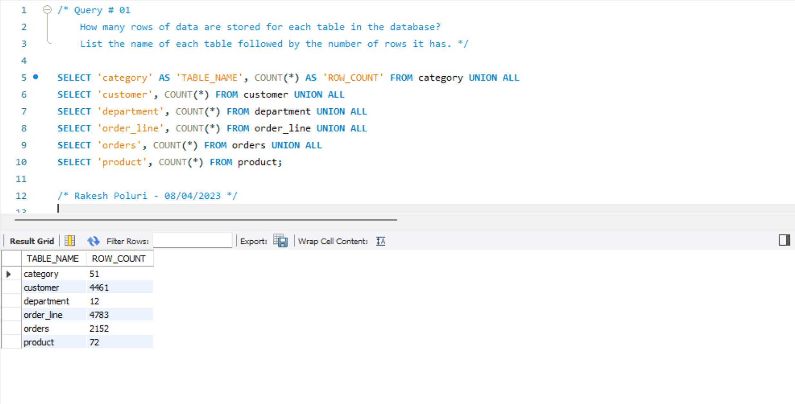

**Query # 02**

SELECT p.product_name AS Product_Name, p.product_price AS Product_Price

FROM product p

WHERE p.product_price > 100.0

ORDER BY p.product_name ASC;

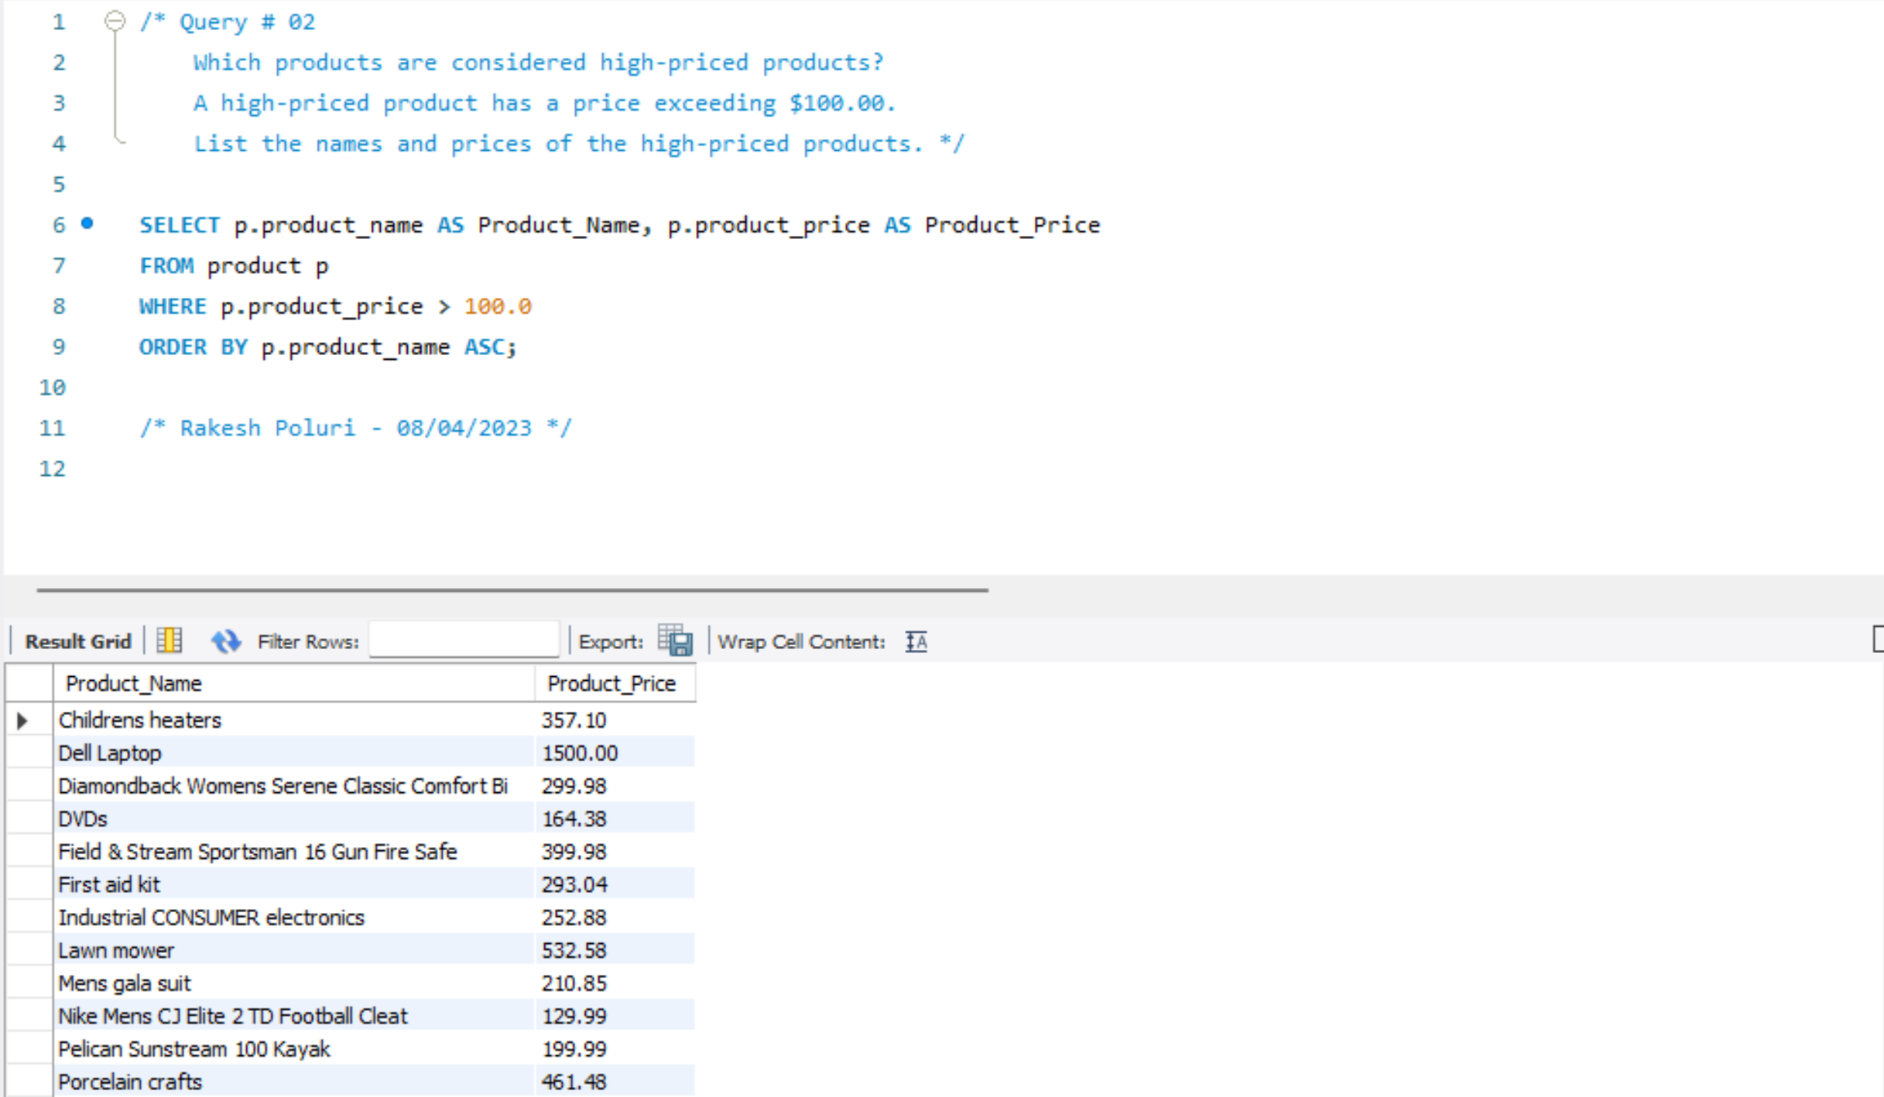

**Query # 03**

SELECT c.first_name, c.last_name, c.city, c.segment, o.order_id, o.order_date

FROM customer c

INNER JOIN orders o ON o.customer_Id = c.customer_id

WHERE c.state = 'FL'

ORDER BY o.order_date ASC;

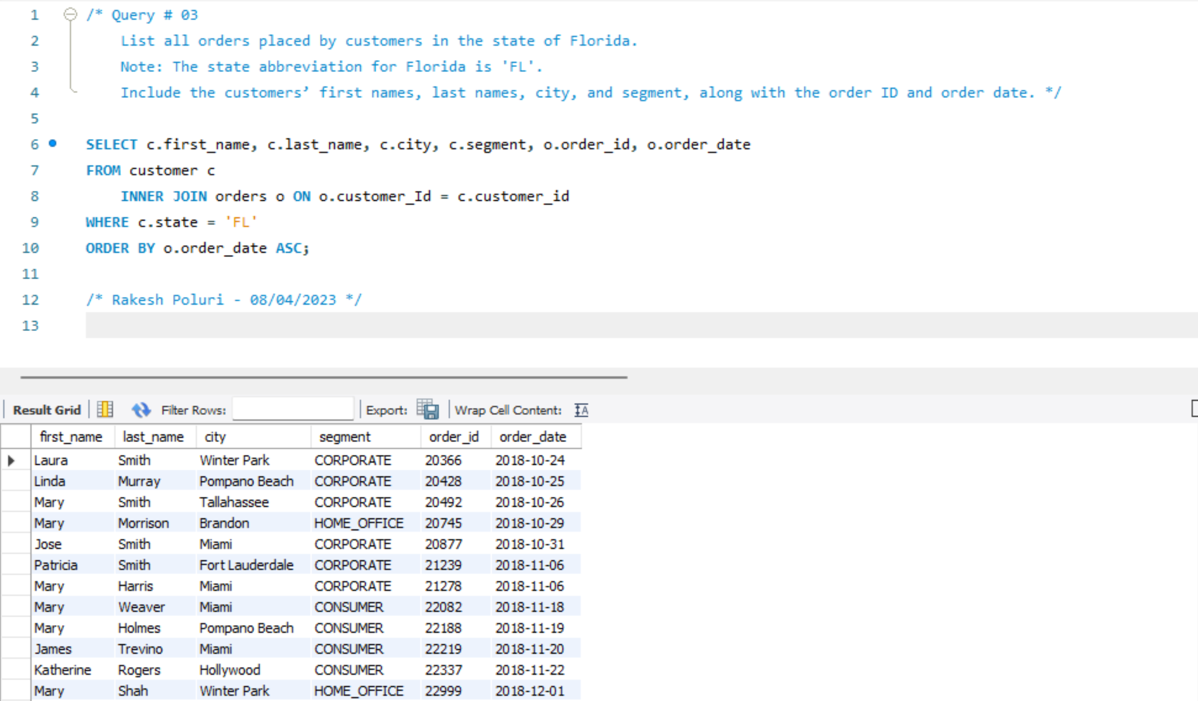

**Query # 04**

SELECT p.product_name, cat.category_name, d.department_name, p.product_price

FROM product p

INNER JOIN category cat ON cat.category_id = p.category_id

INNER JOIN department d ON d.department_id = p.department_id

WHERE cat.category_name IN ('Computers', 'Toys', 'Tennis & Racquet');

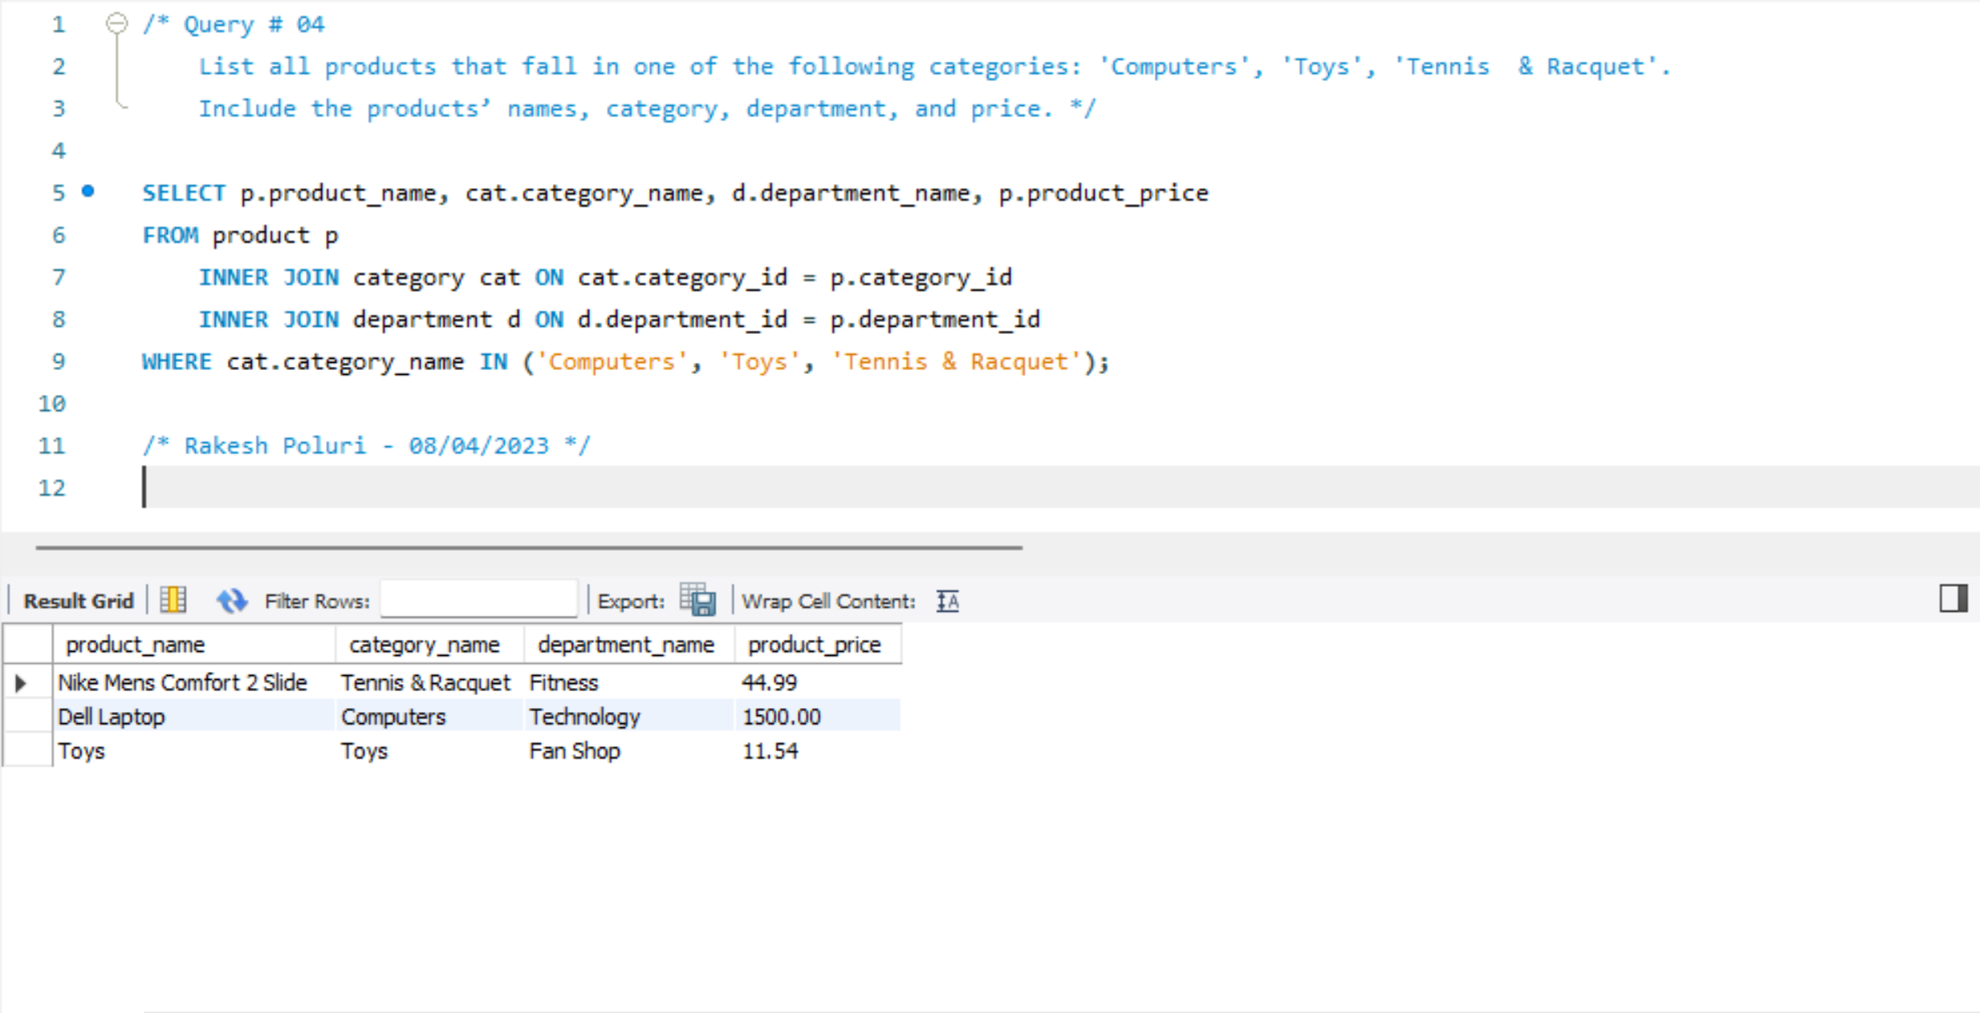

**Query # 05**

SELECT p.product_name, cat.category_name, d.department_name

FROM product p

INNER JOIN category cat ON cat.category_id = p.category_id

INNER JOIN department d ON d.department_id = p.department_id

INNER JOIN order_line ol ON ol.product_id = p.product_id

WHERE ol.quantity_sold = 0;

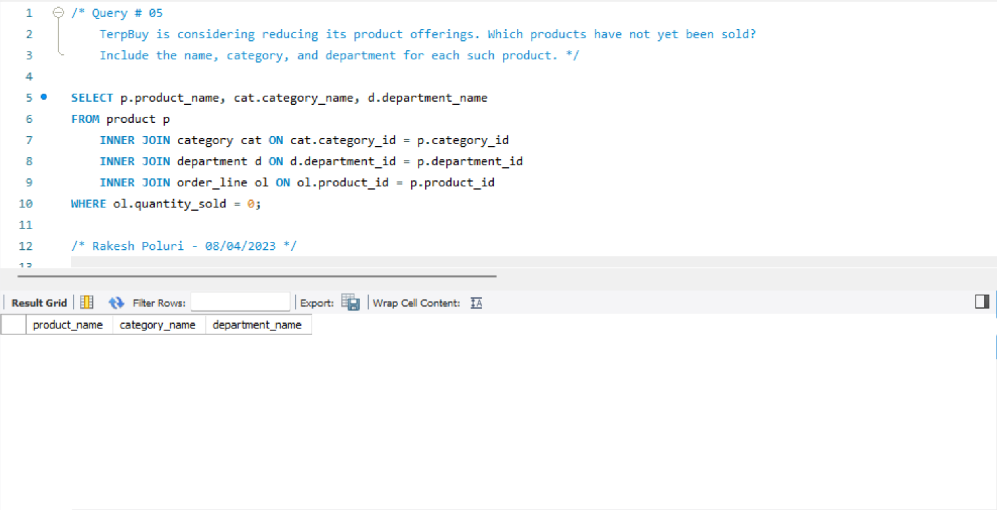

**Query # 06**

SELECT o.order_city AS Order_City, COUNT(o.actual_shipping_days- o.scheduled_shipping_days ) AS Delayed_Orders

FROM orders o

WHERE o.actual_shipping_days- o.scheduled_shipping_days > 0

GROUP BY o.order_city

ORDER BY Delayed_Orders DESC;

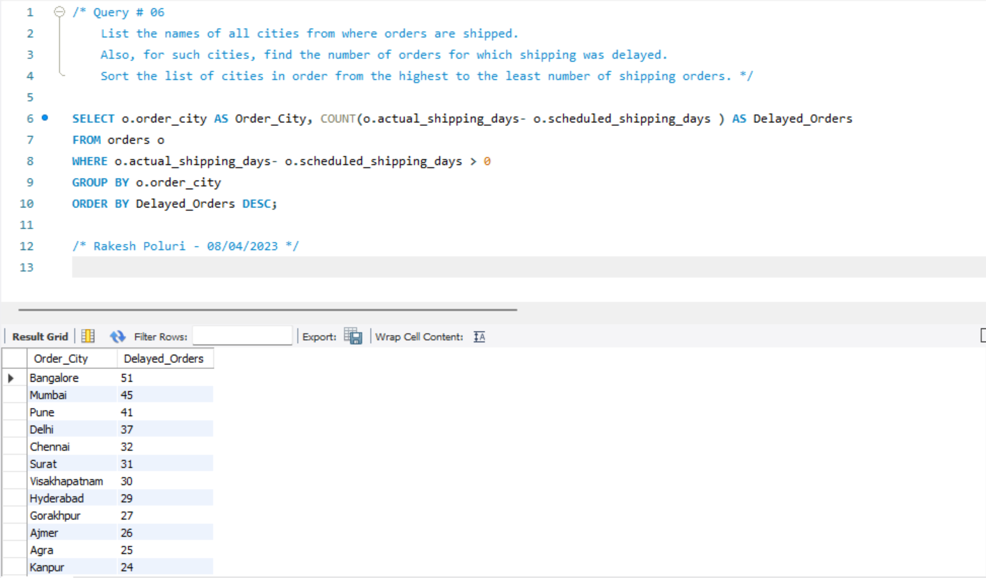

**Query # 07**

SELECT c.segment AS Segment, COUNT(c.customer_id) AS Number_Of_Customers

FROM customer c

GROUP BY c.segment

ORDER BY COUNT(c.customer_id) DESC;

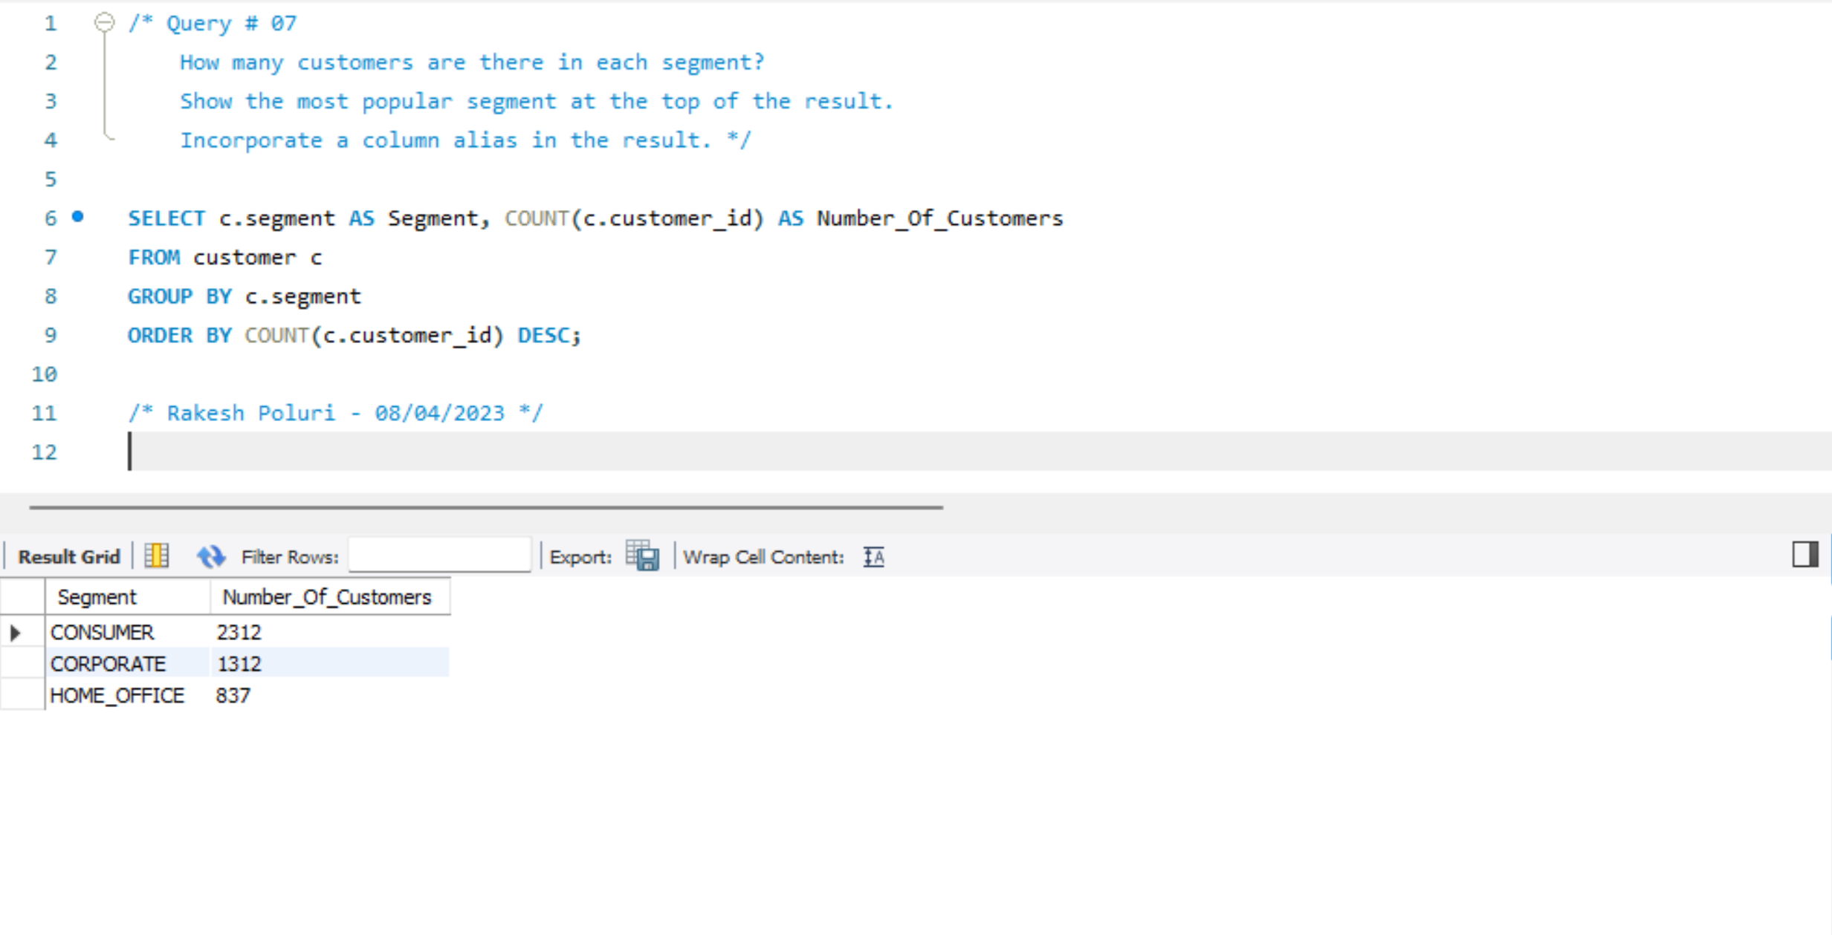

**Query # 08**

SELECT COUNT(o.order_date) as 'Number of Orders in 1st Quarter of 2021'

FROM orders o

WHERE YEAR(o.order_date) = 2021 AND QUARTER(o.order_date) = 1;

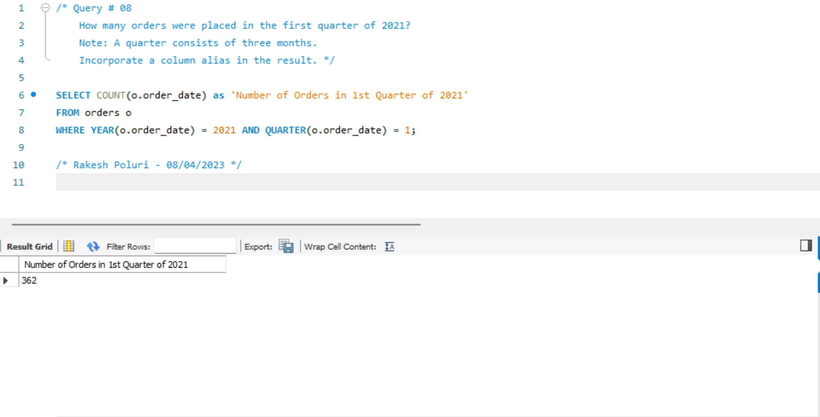

**Query # 09**

SELECT c.state AS State, COUNT(DISTINCT c.segment) AS Count_Of_Segments

FROM customer c

GROUP BY c.state

HAVING COUNT(DISTINCT c.segment) > 1

ORDER BY c.state ASC;

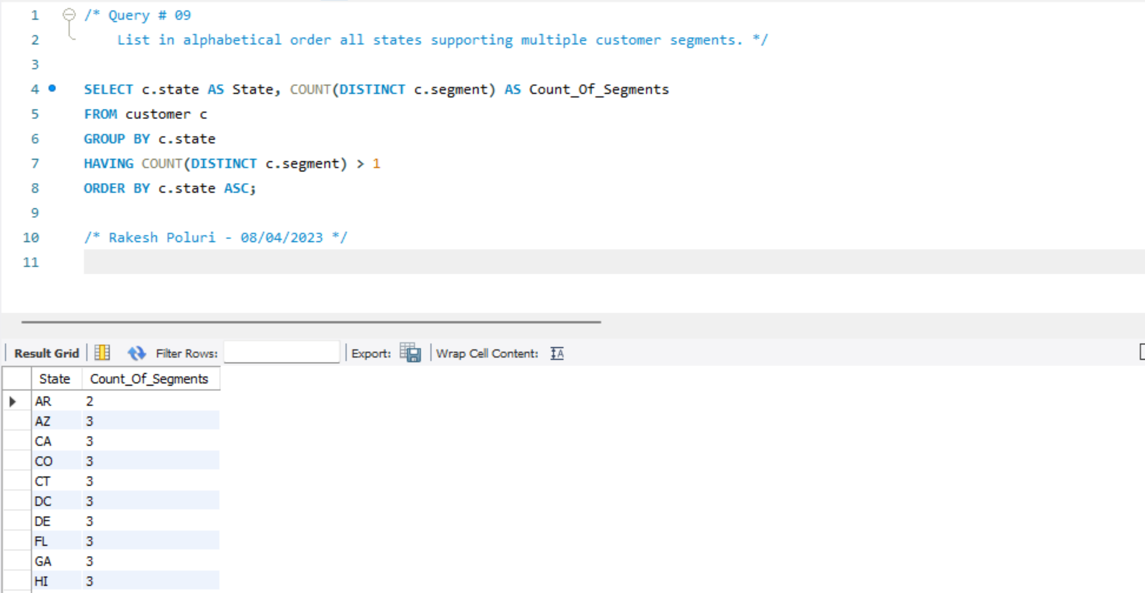

**Query # 10**

SELECT c.first_name, c.last_name, c.street, c.city, c.state, c.zipcode

FROM customer c

LEFT OUTER JOIN orders o ON o.customer_id = c.customer_id

WHERE c.segment = 'CORPORATE' AND o.order_id IS NULL

ORDER BY c.last_name ASC, c.first_name ASC;

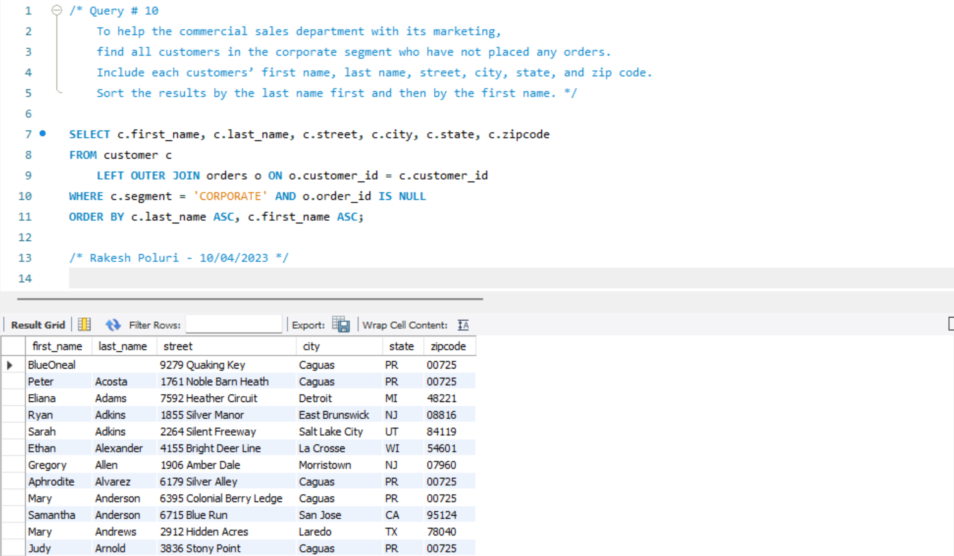

**Query # 11**

SELECT DISTINCT c.first_name, c.last_name, c.street, c.state, c.zipcode, MAX(o.order_date) AS order_date

FROM order_line AS ol

INNER JOIN orders AS o ON o.order_id = ol.order_id

INNER JOIN customer AS c ON c.customer_id = o.customer_Id

INNER JOIN product AS p ON p.product_id = ol.product_id

WHERE p.product_name = 'Nike Mens Free 5.0+ Running Shoe'

GROUP BY c.first_name, c.last_name, c.street, c.state, c.zipcode;

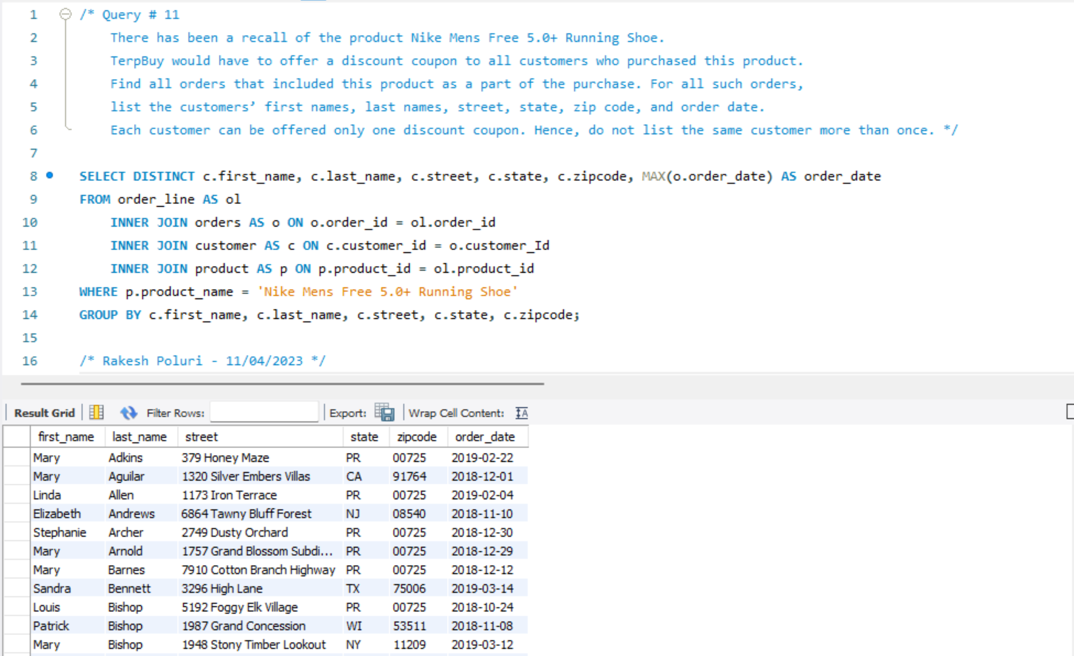

**Query # 12**

SELECT c.first_name, c.last_name, ol.total_price

FROM orders o

INNER JOIN order_line ol ON ol.order_id = o.order_id

INNER JOIN customer c ON c.customer_id = o.customer_Id

WHERE ol.total_price > (

SELECT AVG(ol.total_price)

FROM order_line ol

);

